Networking
What is Computer Networking?
A computer network is a group of interconnected computing devices that can exchange data and share resources with each other.
Basic Building Blocks
- Nodes: Any device capable of sending or receiving data. This includes computers, printers, servers, routers, and switches.
- Links: The communication media connecting the nodes. These can be physical (e.g., copper cables, fiber optic cables) or wireless (e.g., Wi-Fi, Bluetooth, cellular).
- Protocols: A system of rules that networked devices use to format, transmit, and receive data. They act as a common language, allowing different hardware and software to communicate.

Types of Networks (Based on Geographic Area)
Networks are classified primarily by their geographical scope:
Network Type | Acronym | Description | Example
Personal Area Network | PAN | Connects devices within a close range of a single person (up to about 10 meters). | Connecting your phone, smartwatch, and laptop via Bluetooth.
Local Area Network | LAN | Connects devices within a small, limited area, like an office, home, or single building. Provides high-speed data transfer. | A network in a small business office or a home Wi-Fi network.
Metropolitan Area Network | MAN | Spans a geographic area larger than a LAN but smaller than a WAN, typically covering a city or a large campus. | Cable TV network across a city.
Wide Area Network | WAN | Connects networks over long distances, spanning countries or continents. The Internet is the world's largest WAN. | Connecting a company's headquarters in one country to a branch office in another.
Virtual Private Network | VPN | A secure, encrypted connection across a public network (like the Internet) to access a private network. | An employee securely accessing their company's internal network from home.

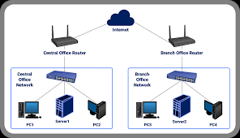
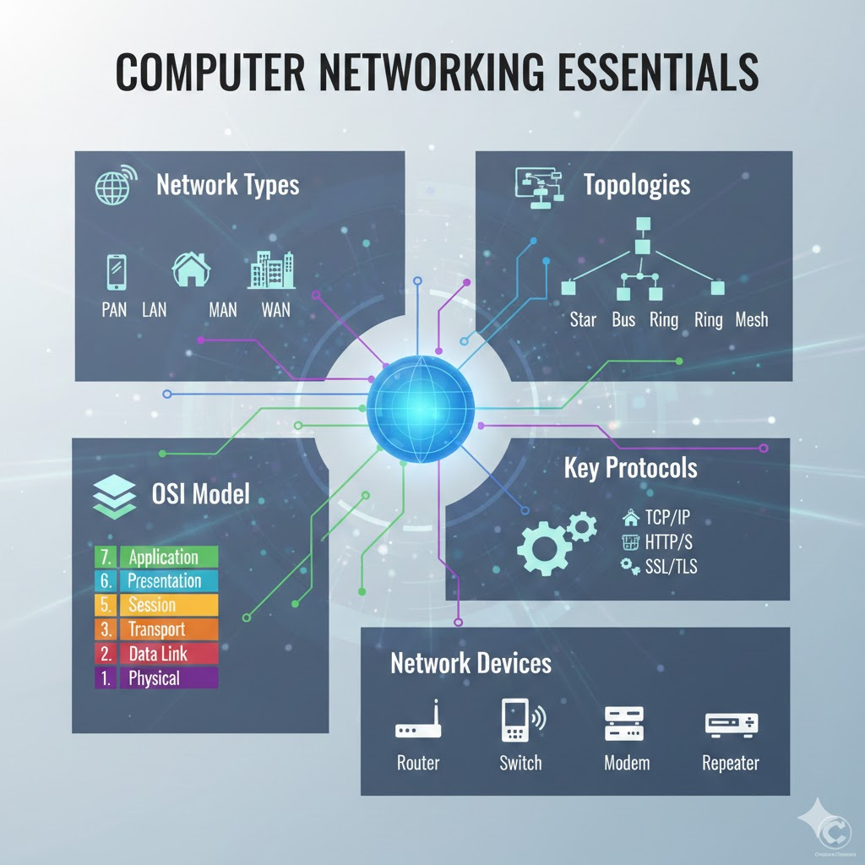
Network Topologies
Network topology describes the physical or logical arrangement of the elements (nodes and links) of a communication network.
Topology | Description | Key Feature
Star | All devices connect directly to a single, central hub or switch. | Easy to install and manage. Failure of one device doesn't affect others, but the central hub is a single point of failure.
Bus | All devices are connected to a single, main communication cable (the backbone). | Simple and requires less cable, but a break in the main cable takes down the whole network.
Ring | Devices are connected in a circular fashion, with each device connected to exactly two others. | Data flows in one direction (or two in a dual ring). Failure of a single link or device can disable the entire network.
Mesh | Every device is connected to every other device on the network. | Full Mesh offers maximum redundancy and reliability, but requires many cables ($n(n-1)/2$ connections for $n$ devices).
Tree | A hierarchical structure that combines characteristics of bus and star topologies. | Used in large organizations for easy expansion and management.

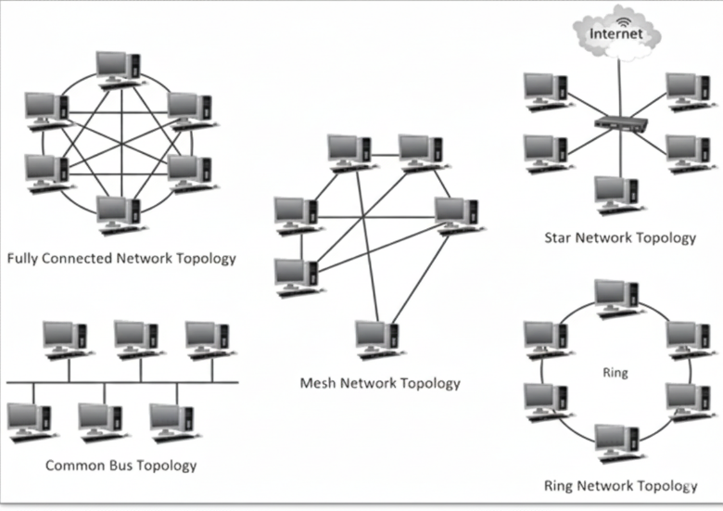
Essential Network Devices
These hardware components facilitate the transmission and management of data across a network:
- Router: A device that forwards data packets between computer networks. It uses IP addresses to determine the best path for data to reach its destination.
- Switch: Connects multiple devices within a single LAN. It is more "intelligent" than a hub, sending data only to the intended destination device using its MAC address.
- Modem (Modulator-Demodulator): Converts digital signals from a computer into analog signals for transmission over traditional media (like phone lines or cable), and vice-versa.
- Hub: A basic device that connects multiple computers. It simply sends incoming data to all connected devices. (Largely replaced by Switches).
- Repeater: Regenerates (boosts) an incoming signal to extend the distance it can travel, overcoming signal degradation.
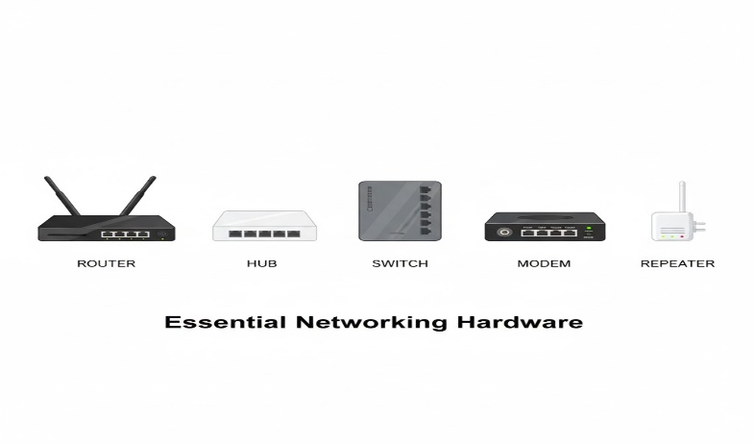

Network Protocols and the OSI Model
Protocols are the rule sets for communication. They are often described in the context of the OSI (Open Systems Interconnection) Model, a conceptual framework that standardizes the functions of a communication system into seven abstraction layers.
OSI Layer | Name | Function/Purpose | Key Protocols
7 | Application | Provides the interface for end-user applications to access network services. | HTTP, HTTPS, FTP, SMTP, DNS
6 | Presentation | Handles data formatting, encryption/decryption, and compression. | JPEG, MPEG, SSL/TLS (often bundled here)
5 | Session | Manages sessions (connections) between applications. | NetBIOS, RPC
4 | Transport | Manages data transfer end-to-end, ensuring complete and correct delivery. | TCP (reliable, connection-oriented), UDP (fast, connectionless)
3 | Network | Handles logical addressing and routing of data packets across different networks. | IP (Internet Protocol), ICMP, BGP
2 | Data Link | Provides node-to-node data transfer and error detection within a physical link. | Ethernet, Wi-Fi (IEEE 802.11)
1 | Physical | Transmits raw bit stream over a physical medium. | Cables (copper, fiber), radio frequencies.
Key Protocols Explained:
- TCP/IP (Transmission Control Protocol/Internet Protocol): The foundational protocol suite of the Internet. IP handles addressing and routing, while TCP ensures that data is reliably delivered in the correct order.
- HTTP (Hypertext Transfer Protocol): The protocol used for transferring data (like web pages) over the World Wide Web.
- HTTPS (HTTP Secure): The secure version of HTTP, using SSL/TLS (Secure Sockets Layer/Transport Layer Security) to encrypt the data between the browser and the web server.

